|  |  |  |
| --- | --- | --- |
|  | **BOSTON**  **UNIVERSITY** | **METROPOLITAN COLLEGE**  **DEPARTMENT OF ADMINISTRATIVE SCIENCES** |

**AD 688 Web Analytics**

**Used Toyota 4Runners Managerial Report**

By: Syretta Meeks

Date: 4/5/2025

Contents

Introduction 3

Price Distribution Analysis 4

Mileage Analysis 6

Depreciation Analysis 6

Conclusion 8

# Introduction

I've conducted a comprehensive analysis of Toyota vehicle pricing and depreciation across Boston, MA and Ocean Springs, MS. The dataset contains information on 618 Toyota vehicles, primarily consisting of 4Runners and Tacoma’s with various trim levels, years, and mileage. This report presents my findings on price distributions, depreciation patterns, and provides specific recommendations for 3-year-old vehicles. The price range spans from $4,995 to $71,990, while mileage ranges from as low as 5 miles to as high as 278,000 miles. This diverse dataset provides a foundation for analyzing market differences between the two locations.

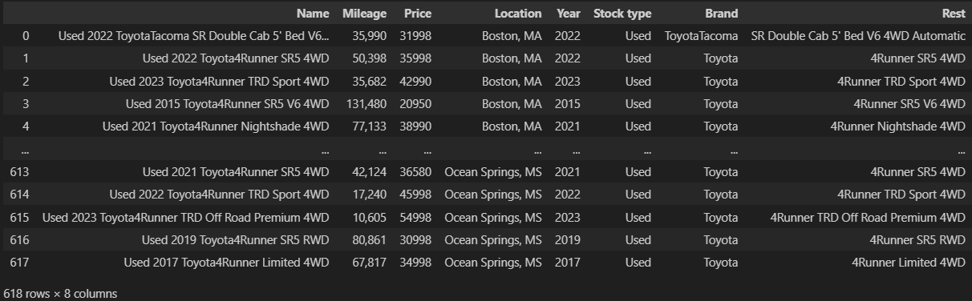

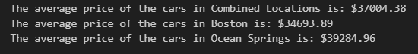

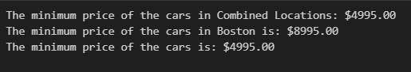

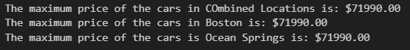

# Price Distribution Analysis

The analysis reveals price differences between the two markets. The combined average price across both locations is $37,004.38, with Boston averaging $34,693.89 and Ocean Springs has a higher $39,284.96. This represents a notable 13.2% premium in the Ocean Springs market compared to Boston.

Premium (%) = (Ocean Springs Avg Price−Boston Avg Price​/ Boston Avg Price) ×100

= (34,693.8939,284.96−34,693.89​) × 100

= (34,693.894,591.07​) × 100

= 0.1323×100=13.23%​

=0.1323×100=13.23%​

=0.1323×100=13.23%​

The price distribution histograms clearly illustrate different market characteristics. Boston's distribution shows a peak frequency around $35,000 with a more concentrated distribution and fewer vehicles in higher price ranges. In contrast, Ocean Springs shows a higher concentration of vehicles in the $35,000-$45,000 range with more even distribution across price points and greater representation in premium pricing above $45,000.

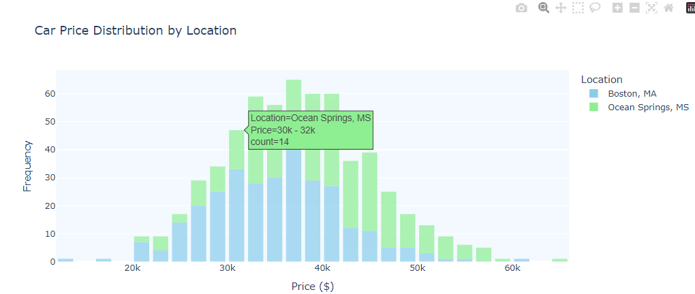

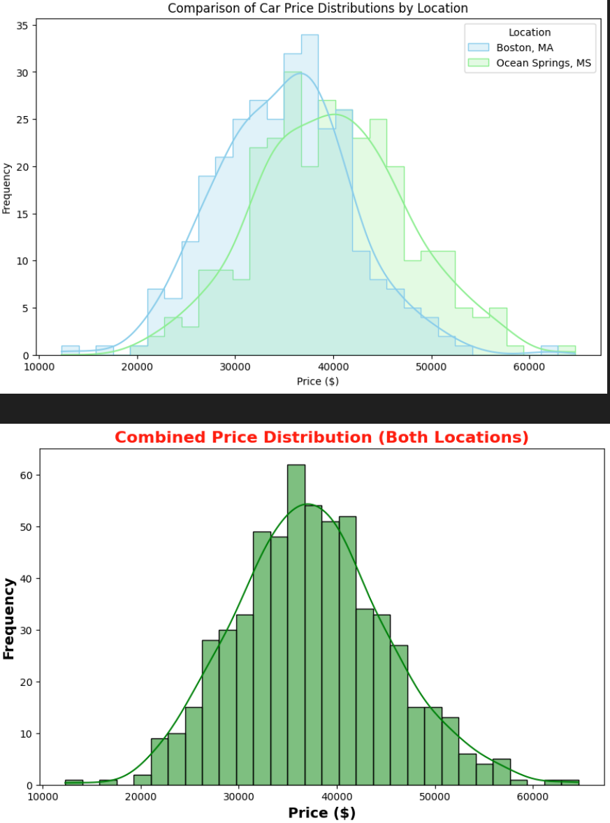

The log price distributions show clear differences between the two markets, with Ocean Springs consistently showing higher prices for comparable vehicle types. The comparison overlay visually reinforces these trends, while also showing that both markets share a similar overall distribution shape.

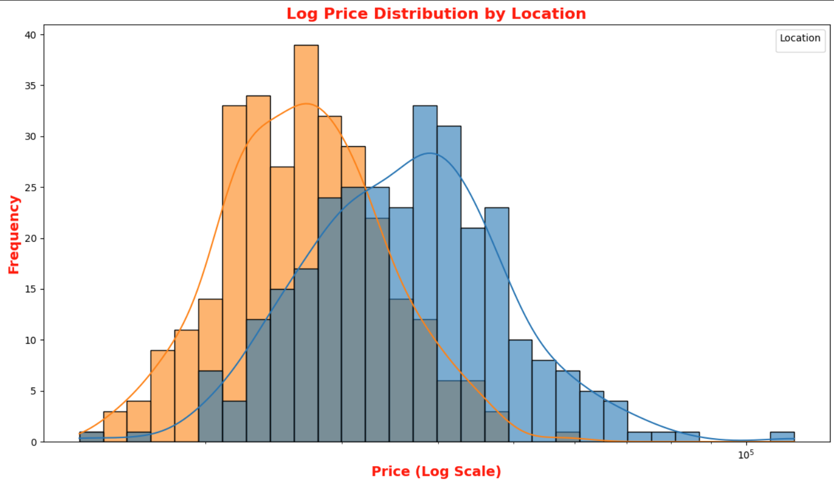

# Mileage Analysis

The mileage statistics reveal interesting patterns across both markets. The combined total mileage across all vehicles is 33,107,381 miles, with Boston accounting for 17,001,570 miles and Ocean Springs for 16,105,811 miles. The minimum mileage is nearly identical (5 miles in Boston, 6 miles in Ocean Springs), while the maximum mileage shows some variation (278,000 miles in Boston versus 257,606 miles in Ocean Springs).

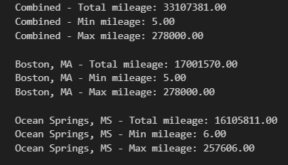

These figures suggest similar usage patterns across both markets, with slightly higher maximum mileage in Boston. The similarity in mileage distribution suggests that price differences are not primarily driven by mileage factors but rather by market-specific conditions.

# Depreciation Analysis

The depreciation data shows distinct patterns between locations that impact vehicle valuation over time. Boston exhibits more favorable depreciation characteristics for owners, with recent models (2022-2023) showing minimal depreciation between 0.96% and 2.95%. Mid-range models (2015-2020) show moderate depreciation between 1.56% and 4.77%, while older models (2011-2014) display higher depreciation rates between 4.13% and 5.32%.

(Images on next page)

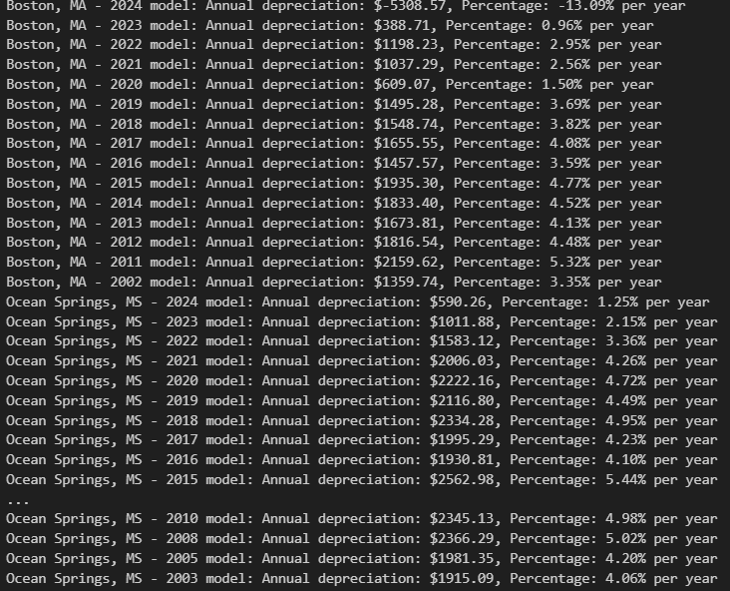

The Toyota 4Runner depreciation scatter plot visually confirms these differences, showing distinct regression lines with different slopes. Despite the faster depreciation in Ocean Springs, the higher initial prices mean that vehicles there still command premium pricing compared to Boston equivalents across most age ranges.

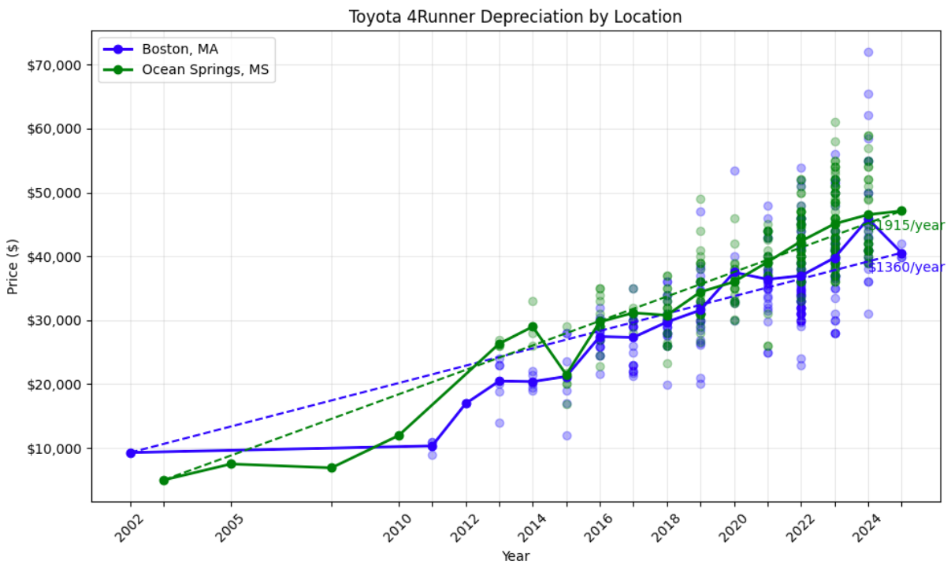

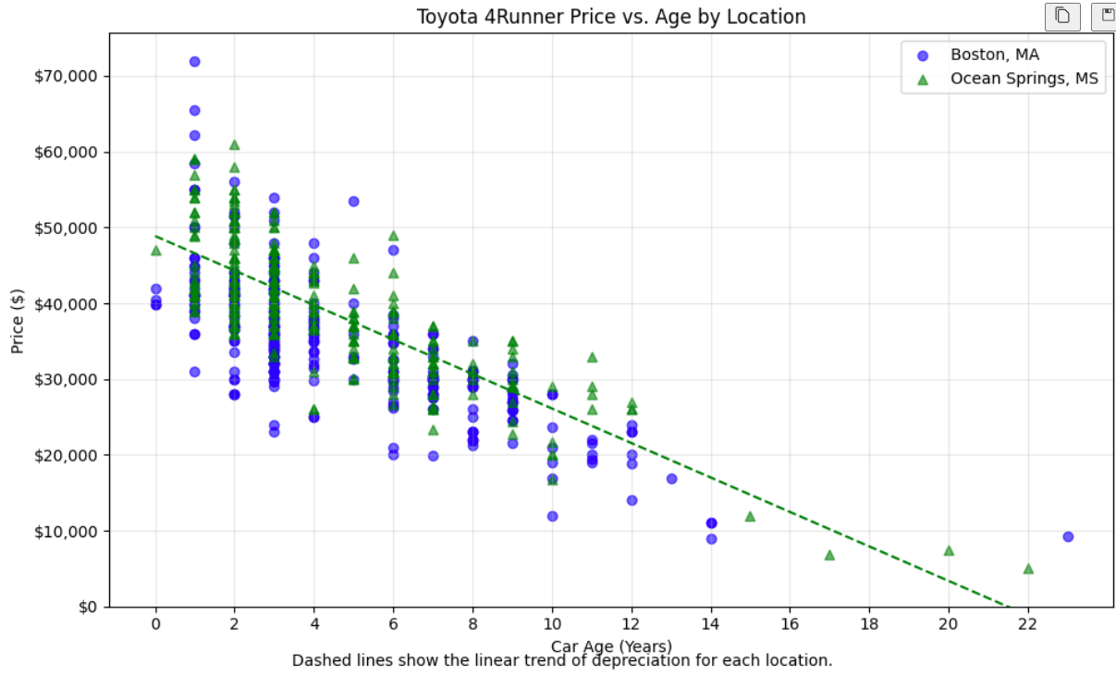

# Conclusion

My analysis reveals distinct market analysis between Boston and Ocean Springs that impact both buyers and sellers. Ocean Springs consistently maintains higher prices across all model years and conditions, creating a market premium of approximately 13%. However, Boston vehicles tend to retain value better over time, with slower depreciation rates compared to Ocean Springs.

For consumers, these findings suggest different strategies depending on location and goals. Purchasing in Boston offers better long-term value retention, while Ocean Springs may provide better selling opportunities for relatively new vehicles. Dealerships could optimize inventory by considering these regional differences in pricing and depreciation when transferring stock between locations.